a lEVEL

COMPUTER SCIENCE PROJECT

Computer Game [Shadow Slash]

Contents

Analysis 2

The Problem 3

Why the program is computational? 3

Stakeholder 3

Research 3

Features 3

Limitations 3

Requirements 4

Success Criteria 4

# Analysis

## The Problem

The immersion of games. The concept is given to those who are immersed in games believing that they are within the game itself. When people play games, it allows them to leave the real world. It allows people to forget their struggles and problems. In addition, games are a fantastic way to rethink and take different approaches to real-world struggles. Why? Well because games allow people to take breaks from using their brain; it reduces stress by creating a flow of sensation and satisfaction – similar to meditation. When people are stressed, they tend to take a different perspective of the situation by changing their pace of workflow which is the main reason I am creating a game. One way to combat stress is to use combat itself. Creating a game that is fast pace and requires the player to focus, allows the concentration to be shifted away from the stressful stimuli. But why a video game? Well, video games are engaging. Unlike taking a stroll in the park, video games allow people to completely forget about stress. Taking a stroll in the park, even though for some it relieves the pressure, for many since there isn’t anything for the brain to be distracted with, the brain signals out the stimuli, causing the person to be possessed with the stress. The program is going to be a 2-dimensional ‘Hack and Slash’. This is where combat is emphasized with melee-based weapons. The aim of the game is for the player to defeat waves of enemies, and reach a high score. Therefore, the main purpose of the action-packed and fast pace Hack and Slash will be for the player to be immersed in the realms of the game to mitigate stress.

## Why the program is computational?

Games heavily rely on computational methods. Without computational methods, the idea of creating a game will be so overly complex, that games, in general, won’t have a place in the market. Therefore, for many games, different methods are required in order to create a successful game. One way in which my Hack and Slash game utilises these methods is the use of decomposition. By breaking down the functionality, I am able to make sub-functions for the sprite, actions, camera, and many other sub-layers that conclude the foundation of the final game. The main sub function is pathfinding/pathing. This is the concept of items finding the shortest route to the final destination. For that reason, the enemies are going to be using pathing to track the position of the player.

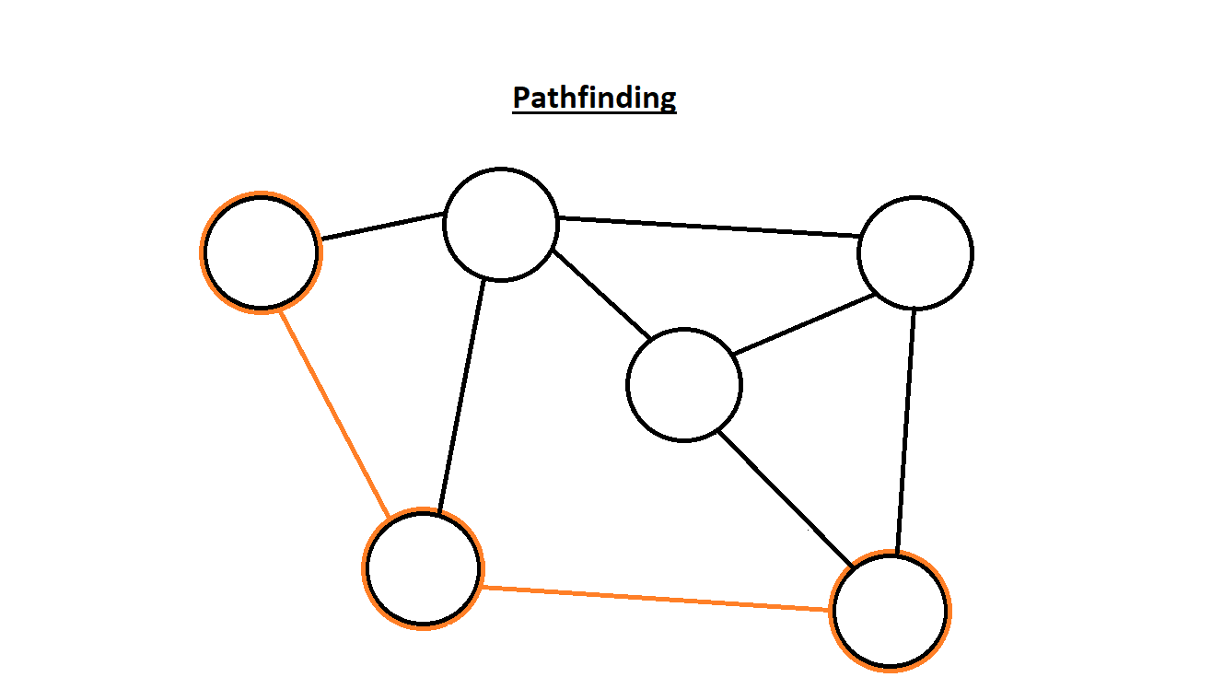

The illustration on the left tells us how pathing works. We know that pathing allows objects to follow the shortest route to their destination. Therefore, the illustration shows that the orange outlines are the fastest route to the destination compared to the other possible routes. With this in mind, I am going to be implementing a similar design for the enemy pathing.  
Furthermore, another computational method that is going to be used is calculations. Without calculations, players will be incapable of doing any basic movement. Additionally, calculations are going to be a vital implementation of the game, since it is heavily relied upon calculating the damage done and taken.

On top of the other computational methods, the use of abstractions is going to essential for the game. Without separating ideas from reality, the game will get overly complex. The main reason is because having a complex concept of the game will cause; firstly, the programmer unable to understand what they are coding and secondly, the player unable to understand the concept of the game. Without a good vision of what the game is supposed to do in its most basic form, just the thought of playing it will become useless. By ignoring the unimportant detail and focusing of the most important parts, it’ll allows me to scope out the functionality and key sections of the game.

## Stakeholder

The target audience of the program is people who play games. Those who are interested in the classic hack and slash games or puzzle–action games will have the most enjoyment from the game.

## Research

## Features

## Limitations

## Requirements

## Success Criteria